Proyecto Final. Generación de imágenes tomográficas por medio de una GAN.

Andrés González Flores. *Facultad de Ingeniería. UNAM*.

**Resumen**—These instructions give you guidelines for preparing papers for IEEE Computer Society Transactions. Use this document as a template if you are using Microsoft Word 6.0 or later. Otherwise, use this document as an instruction set. Please note that use of IEEE Computer Society templates is meant to assist authors in correctly formatting manuscripts for final submission and does not guarantee how the final paper will be formatted by IEEE Computer Society staff. This template may be used for initial submissions; however, please consult the author submission guidelines for formatting instructions as most journals prefer single column format for peer review. An abstract should be 100 to 200 words for regular papers, no more than 50 words for short papers and comments, and should clearly state the nature and significance of the paper. Abstracts *must not* include mathematical expressions or bibliographic references. Please note that abstracts are formatted as left justified in our editing template (as shown here).

**Index Terms**—Keywords should be taken from the taxonomy (http://www.computer.org/mc/keywords/keywords.htm). Keywords should closely reflect the topic and should optimally characterize the paper. Use about four key words or phrases in alphabetical order, separated by commas (there should not be a period at the end of the index terms)

xxxx-xxxx/0x/$xx.00 © 200x IEEE Published by the IEEE Computer Society

—————————— ◆ ——————————

# 1 introducción

L

AS Redes Generativas Antagónicas (GANs por sus siglas en inglés) son un tipo de sistema de aprendizaje de máquina inventado por Ian Goodfellow y sus colegas en 2014.

La estructura del sistema consiste en dos modelos entrenados simultáneamente: un modelo generativo G que captura la distribución de los datos y un modelo discrimitativo D que estima la probabilidad que la muestra haya provenido de los datos de entrenamiento en lugar de G. El procedimiento para G es maximizar la probabilidad de que D cometa un error. Esta estructura consiste en un juego minimax de dos jugadores.

# 2 Desarrollo

Detailed submission guidelines can be found on the author resources Web pages. Author resource guidelines are specific to each journal, so please be sure to refer to the correct to <http://www.computer.org/portal/web/peerreviewjournals/author>.

## 2.3 Figures

All tables and figures will be processed as images. You will have the greatest control over the appearance of your figures if you are able to prepare electronic image files. Save them to a file in PostScript (PS) or Encapsulated PostScript (EPS) formats. Use a separate file for each image. File names should be of the form “fig1.ps” or “fig2.eps.”

For more information on how to format your figure or table files for final submission, please go to <http://www.computer.org/portal/web/peerreviewjournals/author#figures> and [View transactions art_guide.pdf (PDF, 4.69MB)](http://www.computer.org/cms/Computer.org/Journal%20templates/transactions_art_guide.pdf).

# 4 Citations

IEEE Computer Society style is to note citations in individual brackets, followed by a comma, e.g. “[1], [5]” (as opposed to the more common “[1, 5]” form.) Citation ranges should be formatted as follows: [1], [2], [3], [4] (as opposed to [1]-[4], which is not IEEE Computer Society style). When citing a section in a book, please give the relevant page numbers [2]. In sentences, refer simply to the reference number, as in [3]. Do not use “Ref. [3]” or “reference [3]” At the beginning of a sentence use the author names instead of “Reference [3],” e.g., “Smith and Smith [3] show ... .” Please note that references will be formatted by IEEE Computer Society production staff in the same order provided by the author.

# 5 Equations

If you are using Word, use the MathType add-on (<http://www.mathtype.com>) for equations in your paper (Insert | Object | Create New | Microsoft Equation or MathType Equation). “Float over text” should not be selected.

For display equations as seen below, number equations consecutively with equation numbers in parentheses flush with the right margin, as in (1). First, use the equation editor to create the equation. Then, select the “Equation” markup style. Press the tab key and write the equation number in parentheses. To make your equations more compact, you may use the solidus ( / ), the exp function, or appropriate exponents. Use parentheses to avoid ambiguities in denominators. Punctuate equations when they are part of a sentence, as in

 (1)

Be sure that the symbols in your equation have been defined before the equation appears or immediately following. Italicize symbols (*T* might refer to temperature, but T is the unit tesla). Per IEEE Computer Society, please refer to “(1),” not “Eq. (1)” or “equation (1),” except at the beginning of a sentence: “Equation (1) shows ... .” Also see *The Handbook of Writing for the Mathematical Sciences*, 1993. Published by the Society for Industrial and Applied Mathematics, this handbook provides some helpful information about math typography and other stylistic matters. For further information about typesetting mathematical equations, please visit the IEEE Computer Society style guide: <http://www.computer.org/portal/web/publications/style_math>.

Please note that math equations might need to be reformatted from the original submission for page layout reasons. This includes the possibility that some in-line equations will be made display equations to create better flow in a paragraph. If display equations do not fit in the two-column format, they will also be reformatted. Authors are strongly encouraged to ensure that equations fit in the given column width.

# 6 Helpful Hints

## 6.1 Figures and Tables

Because IEEE Computer Society staff will do the final formatting of your paper, some figures may have to be moved from where they appeared in the original submission. Figures and tables should be sized as they are to appear in print. Figures or tables not correctly sized will be returned to the author for reformatting.

Detailed information about the creation and submission of images for articles can be found at <http://www.computer.org/portal/web/peerreviewjournals/author#figures> where you can [View transactions art_guide.pdf (PDF, 4.69MB)](http://www.computer.org/cms/Computer.org/Journal%20templates/transactions_art_guide.pdf) . We strongly encourage authors to carefully review the material posted here to avoid problems with incorrect files or poorly formatted graphics.

Place figure captions below the figures; place table titles above the tables. Figure captions appear as left justified. Table captions are restricted to one sentence and are formatted as title case. Any additional sentence in a table caption will be formatted as a footnote below the table (see Table 1 in this document). If your figure has two parts, include the labels “(a)” and “(b)” as part of the artwork. Please verify that the figures and tables you mention in the text actually exist. Figures and tables should be called out in sequential order, as this is how they will be placed in your paper. For example, avoid referring to figure “8” in the first paragraph of the article unless figure 8 will again be referred to after the reference to figure 7. **Please do not include figure captions as part of the figure. Do not put captions in “text boxes” linked to the figures. Do not put borders around the outside of your figures.** Per IEEE Computer Society, please use the abbreviation “Fig.” even at the beginning of a sentence. Do not abbreviate “Table.” Tables are numbered numerically.

For journals that use print for publication, please verify with IEEE Computer Society that the journal you are submitting to does indeed accept color before submitting final materials. **Do not use color unless it is necessary for the proper interpretation of your figures.**

Figures (graphs, charts, drawing or tables) should be named fig1.eps, fig2.ps, etc. If your figure has multiple parts, please submit as a single figure. Please do not give them descriptive names. Author photograph files should be named after the author’s LAST name. Please avoid naming files with the author’s first name or an abbreviated version of either name to avoid confusion. If a graphic is to appear in print as black and white, it should be saved and submitted as a black and white file (grayscale or bitmap.) If a graphic is to appear in color, it should be submitted as an RGB color file.

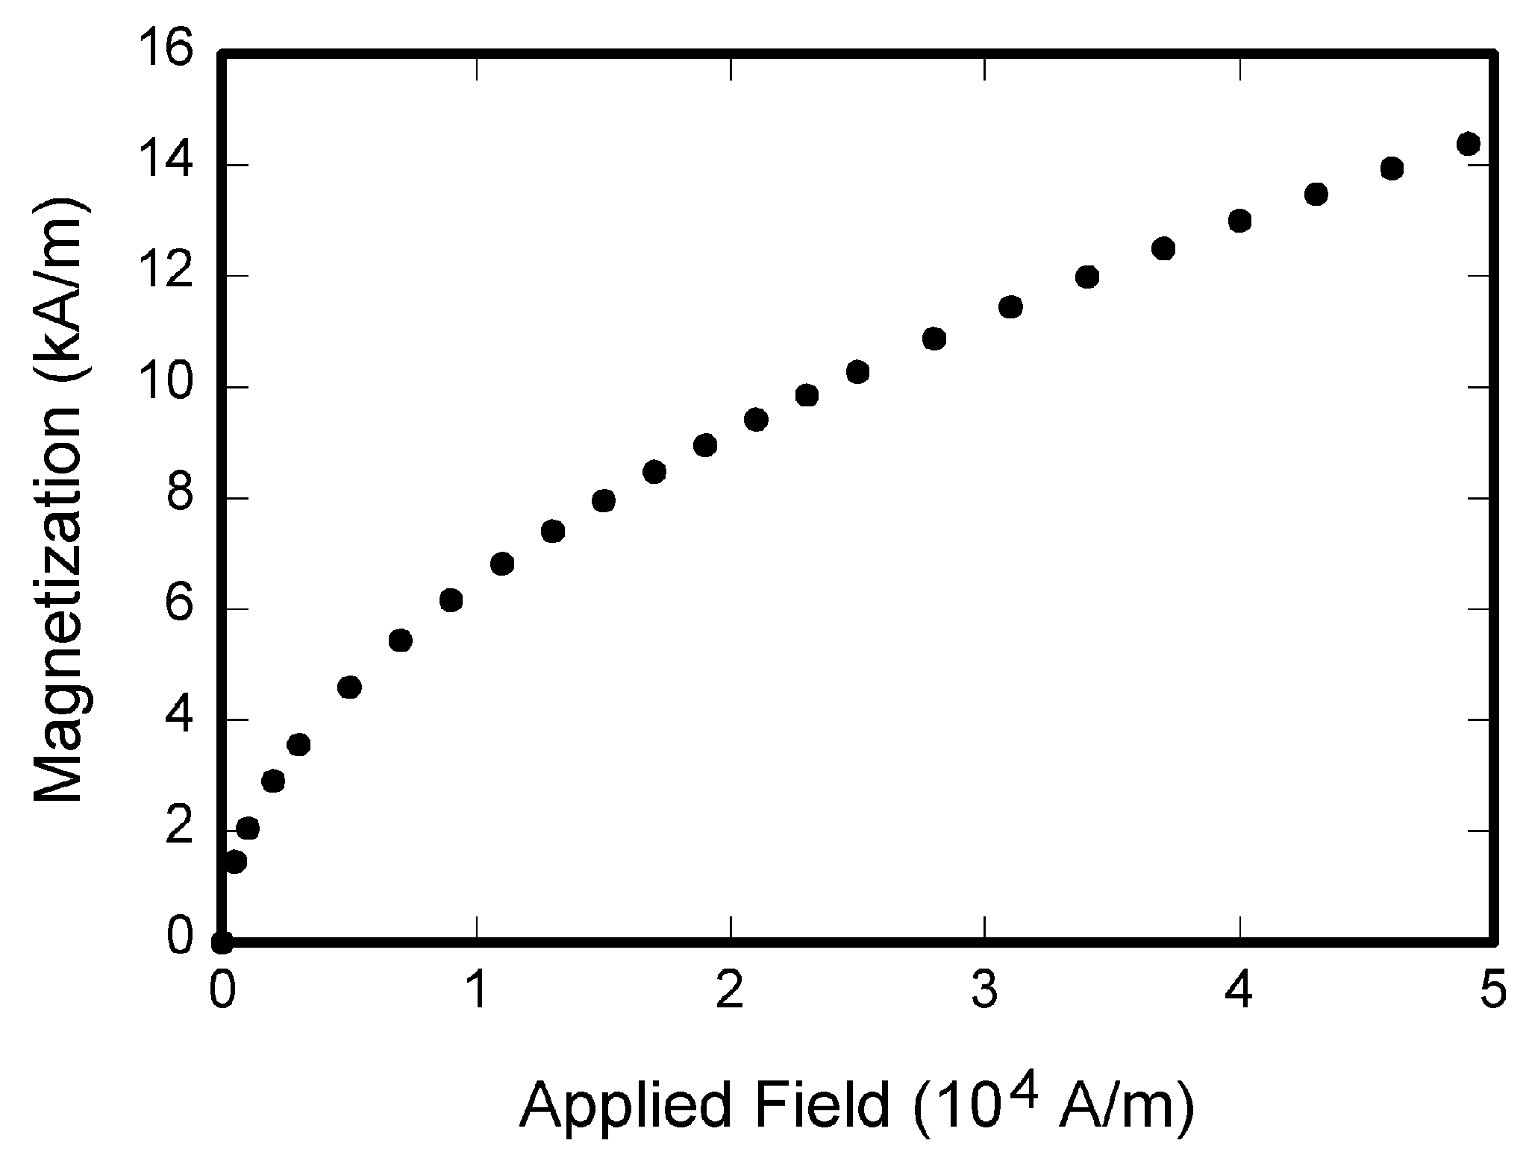

Fig. 1. Magnetization as a function of applied field. Note that “Fig.” is abbreviated. There is a period after the figure number, followed by one space. It is good practice to briefly explain the significance of the figure in the caption.

Figure axis labels are often a source of confusion. Use words rather than symbols. As an example, write the quantity “Magnetization,” or “Magnetization *M*,” not just “*M*.” Put units in parentheses. Do not label axes only with units. As in Fig. 1, for example, write “Magnetization (A/m)” or “Magnetization (Am−1),” not just “A/m.” Do not label axes with a ratio of quantities and units. For example, write “Temperature (K),” not “Temperature/K.” Table 1 shows some examples of units of measure.

Multipliers can be especially confusing. Write “Magnetization (kA/m)” or “Magnetization (103 A/m).” Do not write “Magnetization (A/m) × 1,000” because the reader would not know whether the top axis label in Fig. 1 meant 16,000 A/m or 0.016 A/m. Figure labels should be legible, approximately 8 to 12 point type. When creating your graphics, especially in complex graphs and charts, please ensure that line weights are thick enough that when reproduced at print size, they will still be legible. We suggest at least 1 point.

## 6.3 Footnotes

Number footnotes separately in superscripts (Insert | Footnote)[1]. Place the actual footnote at the bottom of the column in which it is cited; do not put footnotes in the reference list (endnotes). Use letters for table footnotes (see Table 1). Please do not include footnotes in the abstract and avoid using a footnote in the first column of the article. This will cause it to appear above the affiliation box, making the layout look confusing.

TABLE 1  
Units for Magnetic Properties

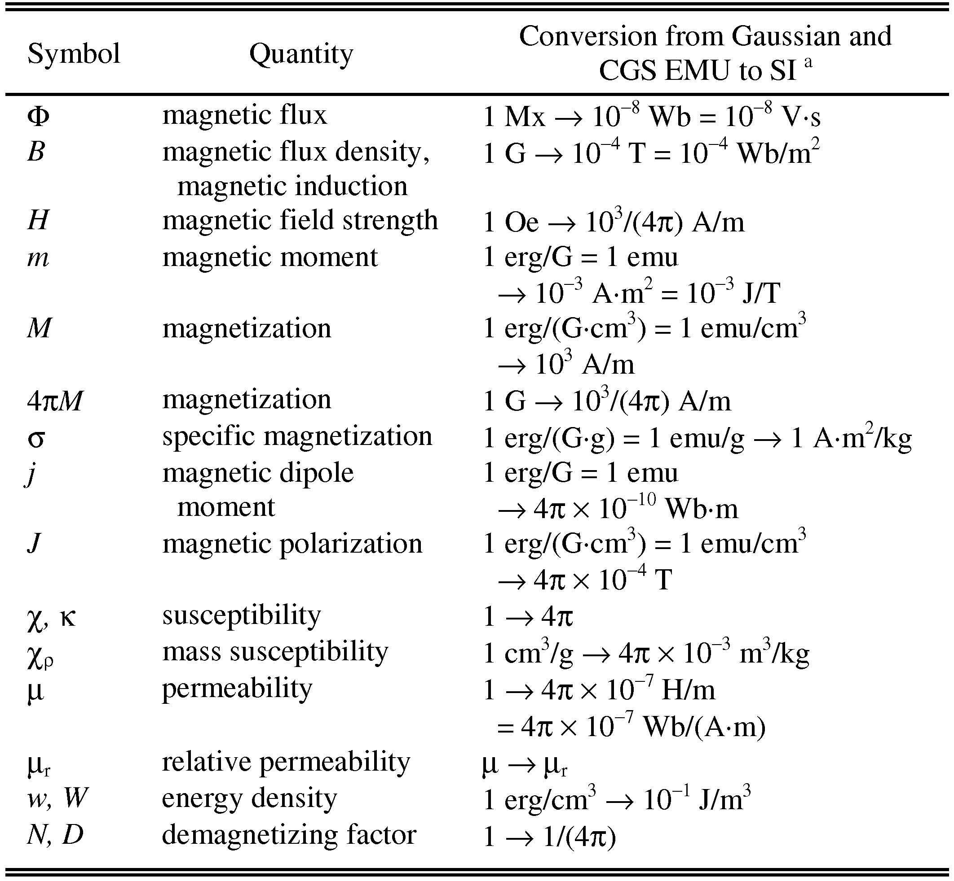

Statements that serve as captions for the entire table do not need footnote letters.

aGaussian units are the same as cgs emu for magnetostatics; Mx = maxwell, G = gauss, Oe = oersted; Wb = weber, V = volt, s = second, T = tesla, m = meter, A = ampere, J = joule, kg = kilogram, H = henry.

## 6.4 Lists

The IEEE Computer Society style is to create displayed lists if the number of items in the list is longer than three. For example, within the text lists would appear 1) using a number, 2) followed by a close parenthesis. However, longer lists will be formatted so that:

1. Items will be set outside of the paragraphs.
2. Items will be punctuated as sentences where it is appropriate.
3. Items will be numbered, followed by a period.

## 6.5 Theorems and Proofs

Theorems and related structures, such as axioms corollaries, and lemmas, are formatted using a hanging indent paragraph. They begin with a title and are followed by the text, in italics.

**Theorem 1.** *Theorems, corollaries, lemmas, and related structures follow this format. They do not need to be numbered, but are generally numbered sequentially.*

Proofs are formatted using the same hanging indent format. However, they are not italicized.

**Proof.** The same format should be used for structures such as remarks, examples, and solutions (though these would not have a Q.E.D. box at the end as a proof does). □

# Conclusion

Although a conclusion may review the main points of the paper, do not replicate the abstract as the conclusion. A conclusion might elaborate on the importance of the work or suggest applications and extensions. Authors are strongly encouraged not to reference multiple figures or tables in the conclusion—these should be referenced in the body of the paper.

**Referencias**

1. GOODFELLOW, Ian, et al. “Generative adversarial nets”. En *Advances in neural information processing systems*. 2014. p. 2672-2680.

**First A. Author** Allbiographies should be limited to one paragraph consisting of the following: sequentially ordered list of degrees, including years achieved; sequentially ordered places of employ concluding with current employment; association with any official journals or conferences; major professional and/or academic achievements, i.e., best paper awards, research grants, etc.; any publication information (number of papers and titles of books published); current research interests; association with any professional associations. Author membership information, e.g., is a member of the IEEE and the IEEE Computer Society, if applicable, is noted at the end of the biography.

**Second B. Author Jr.** biography appears here.

**Third C. Author** biography appears here.

1. It is recommended that footnotes be avoided (except for the unnumbered footnote with the receipt date on the first page). Instead, try to integrate the footnote information into the text.